SPEAK/ EAP Validate Quick Reference
Created: April 1, 2017

The SPEAK/ EAP web application is used to load SPEAK and EAP test scores to the GST Notes table. The Center for Intensive English Studies is responsible for providing the student test scores data and the Graduate School is responsible for uploading this data to the GST Notes table. Since the two departments have different duties, the application identifies the user’s role and only displays the functionality for that role. Included in this document is a Center for Intensive English Studies User’s Quick Guide and the Graduate School User’s Quick Guide.

Center for Intensive English Studies User’s Quick Guide

Access the SPEAK/ EAP Application

To access the SPEAK/ EAP application, open a web browser and paste the link below in the address bar or press the Ctrl key and click the link below.
https://netprod.its.fsu.edu/csgst_speakeap_loader/SpeakEAP_Loader.aspx

Log in using your FSUID and FSU password. The CIES user menu page is shown below. The CIES access level allows the user to upload test score data to the GST Archive table and to review and maintain the GST Archive table.

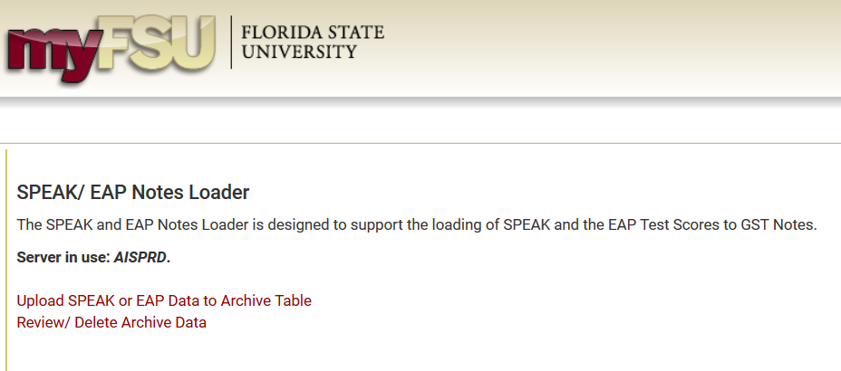

The page has the following features:
- Server in use - displays the environment the application is running in and will always be “AISPROD”. This indicator is more meaningful to the Graduate School user.
- Upload SPEAK or EAP Data to Archive Table – click this button to Upload test scores to the GST Archive table. The Archive table contains validated test scores uploaded by the CIES user. Its use eliminates the need to email sensitive test score data to the Graduate School and also serves as an archive of historical load data.
- Review/ Delete Archive Data – click this button to review or maintain the GST Archive table.

Upload SPEAK or EAP Data to Archive Table

The Upload SPEAK or EAP Data to Archive Table page is used to upload test score data to the GST Archive table (see below). Step 1 in uploading test score data is to define the data to be loaded using the features on the page.

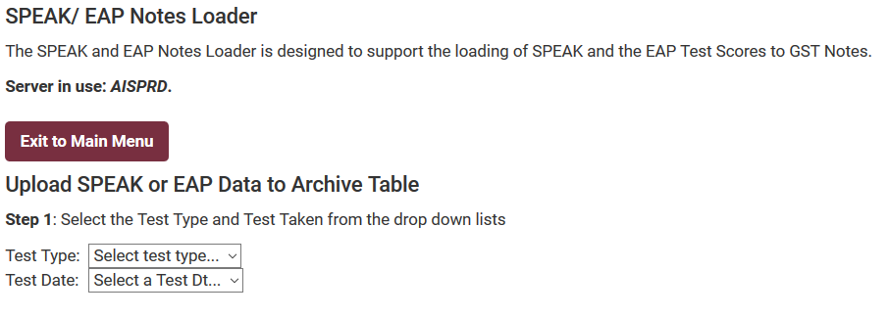

Page features:
- Exit to Main Menu button – click this button to return to the CIES main menu.
- Test Type drop down list - use this drop down list to select the test score data to be loaded, either SPEAK or EAP.
- Test Date drop down list – select the date from this drop down list for which the test score data applies.

SPEAK scores are uploaded based on an excel input file so, when the Test Type selected equals “SPEAK”, the page will display options for the user to select an excel spreadsheet.

EAP scores are loaded based on the enrollment in a university EAP5835 course so, when the Test Type selected equals “EAP”, the page will display all students enrolled in an EAP5835 course and prompt the user to select the students to be included in the upload to the GST Archive table.

Speak Score Upload to GST Archive Table
When “SPEAK” is selected, Step 2 is displayed (see below):

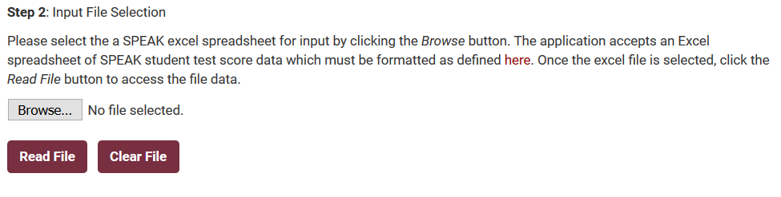

To select an excel spreadsheet of SPEAK test score data, click the Browse button. The page will open a File Explorer popup (as shown below) to allow the user to browse and select the excel input file to be used. Double click the file name or select the file name and click Open in the File Explorer to select a file.

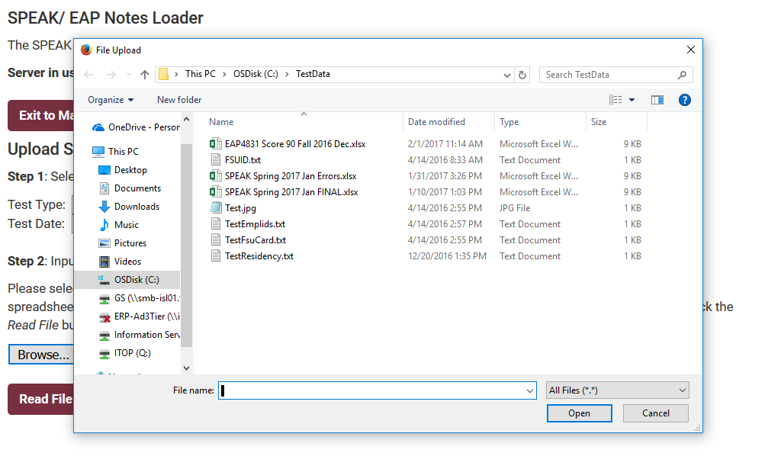

The file name now displays after the Browse button. Click the Read File button to continue or click the Clear File button to clear the selected file name.

When the Read File button is clicked, Step 3 is displayed (as shown below):
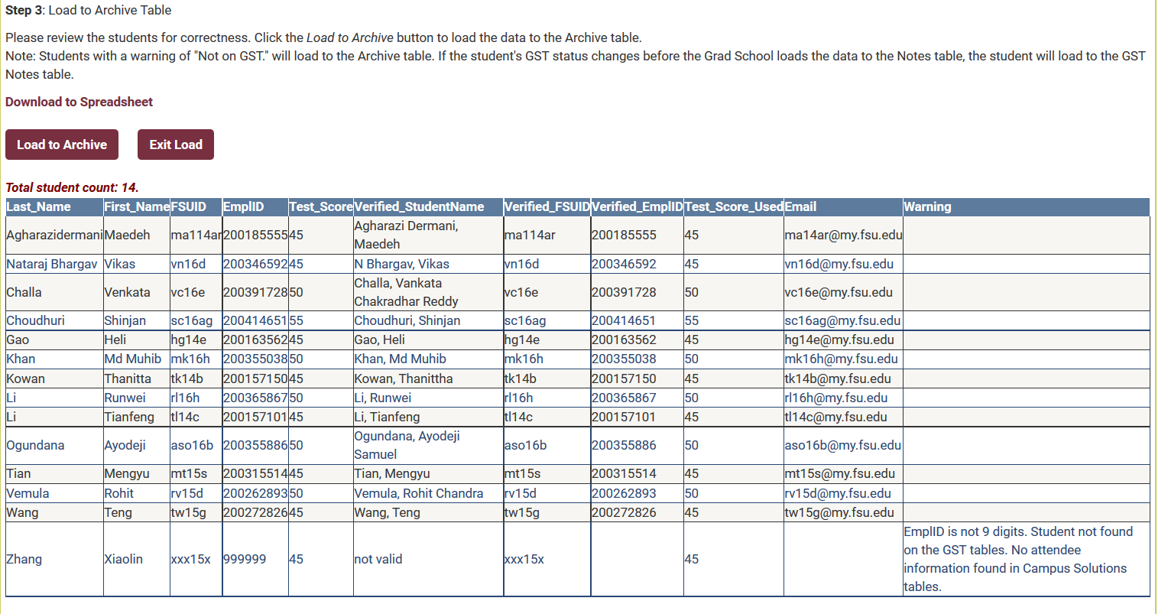

The input data is compared to the Archive table. If the students on the input file have already been loaded to the GST Archive table, they will not appear in the list. In this case, a Students already on archive count is displayed to account for these students. Any students not already uploaded will be displayed in the list.

The excel input file is validated and displayed along with a Warning column. Review the Warning messages for errors. If critical errors are found, correct the original excel spreadsheet and click the Exit Load button or the Clear File button to restart the upload process. If these errors are not corrected, the affected student may not load or load incorrectly.

When the list is clean, click the Load to Archive button to upload the data to the GST Archive table. A new list is displayed (see below) with a Warning and Update Status column. The Warning column contains the original Warning message and the Update Status column contains the load result. Any Update Status message other than ‘Success’ and without a Warning message should be reported to systems.

The upload is complete. An email is sent to the designated Graduate School user to inform them new test score data has been added to the Archive table. They are responsible for uploading the Archive test score data to the GST Notes table.

Click the Exit Load button to return to the Upload SPEAK or EAP Data to Archive Table.
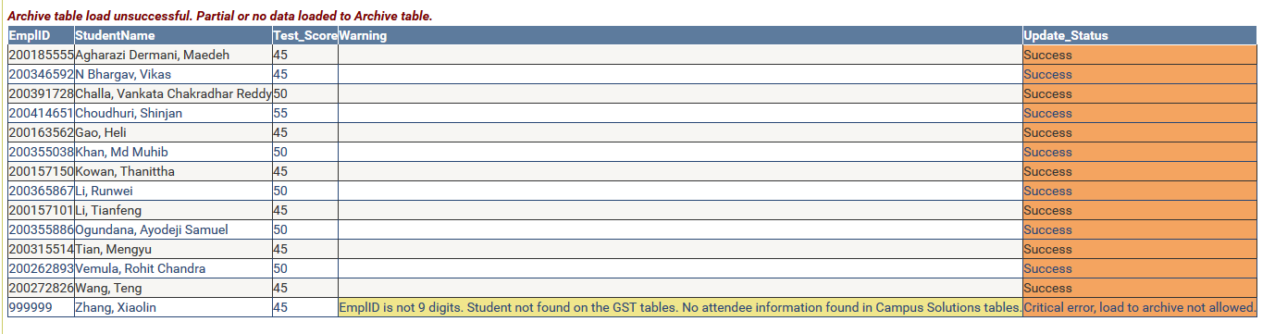

EAP Score Upload to GST Archive Table
When “EAP” is selected, Step 2 is displayed (see below). For the term related to the selected Test Date, all students with an EAP5835 course are displayed.

Check the Select checkbox in the list for each student to be included in the upload to the GST Archive table and then click the Save EAP To List button. To reset the list back to no checkboxes selected, click the Reset EAP List button.

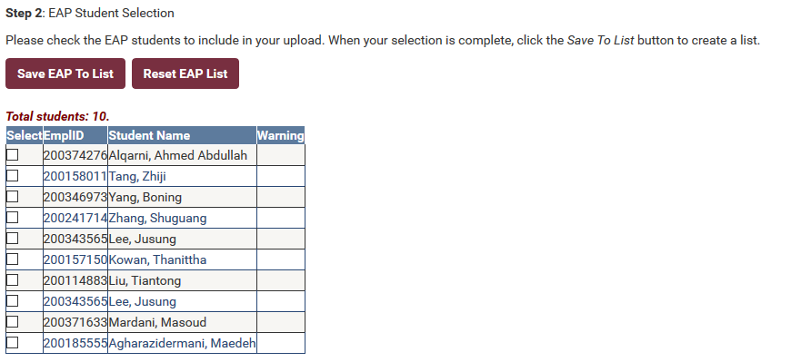

When the Save EAP To List button is clicked, the list is redisplayed with only the students whose checkbox has been checked (see below).

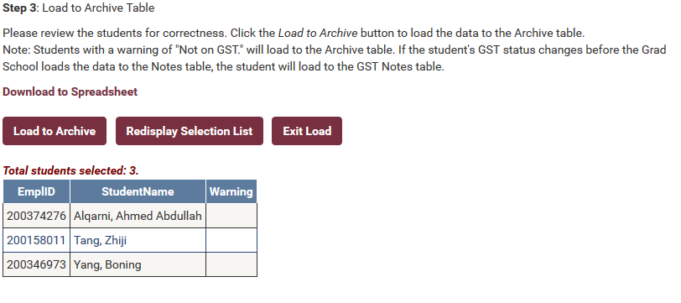

To redisplay the original list, click the Redisplay Selection List button. To return back to the Upload SPEAK or EAP Data to Archive Table section, click the Exit Load button.

To load the displayed data into the GST Archive table, click the Load to Archive button. A new column is added to the display called Update Status to display the results of the upload (see below). Any Update Status other than ‘Success’ should be reported to systems.

The load is complete. An email is sent to the designated Graduate School user to inform them new test score data has been added to the Archive table. They are responsible for uploading the Archive test score data to the GST Notes table.

Click Exit Load to return to the Upload SPEAK or EAP Data to Archive Table section.
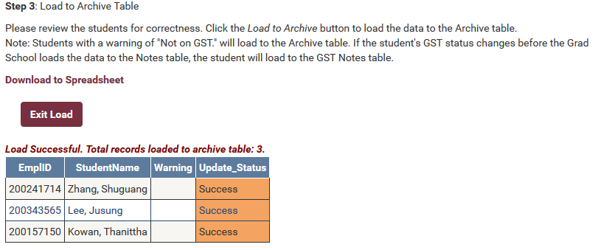
Review/ Delete Archive Data

The CIES user has access to review and, in some cases, delete GST Archive data.

To select data for review, select the Test Type, either SPEAK or EAP, from the Test Type drop down list. The Test Date drop down list is automatically loaded with available test score dates on the Archive table. Select a Test Date from the drop down list and the test score data is display along with available options as shown below.

Page Features:
- Limit display to students not yet loaded to the Notes table – this checkbox limits the student display to only those who have not yet been loaded to the GST Notes table.
- Reset Note Load Dt – the Reset Note Load Dt button should only be used when coordinating the removal of test score data from the GST Notes table with the Graduate School. Clicking this button resets the GST Notes Load Dt which, when present, indicates the test score data has been loaded to the Notes table.
- Delete from Archive – only test score data that has not been loaded to the GST Notes table can be deleted. It is possible to remove these records but the Graduate School would need to be involved to first delete the loaded test score data from the Notes table. The test scores could then be reset by clicking the Reset Note Load Dt button and deleted from the GST Archive table by clicking the Delete from Archive button. At that point, the test score data could be corrected and reloaded to the GST Archive table and uploaded again to the GST Notes table.

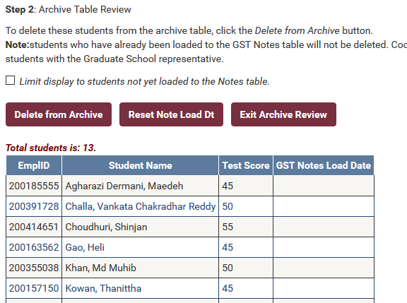
Graduate School User’s Quick Guide

Access the SPEAK/ EAP Application

To access the SPEAK/ EAP application, open a web browser and paste the link below in the address bar or press the Ctrl key and click the link below.
https://netprod.its.fsu.edu/csgst_speakeap_loader/SpeakEAP_Loader.aspx

Log in using your FSUID and FSU password. The CIES user menu page is shown below. The CIES access level allows the user to upload test score data to the GST Archive table and to review and maintain the GST Archive table.
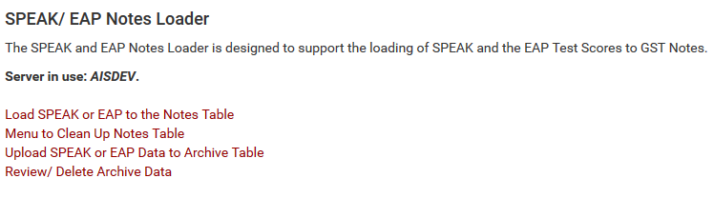

The page has the following features:
- Server in use - displays the environment the application is running in and will always be “AISPROD”. This indicator is more meaningful to the Graduate School user.
- Load SPEAK or EAP to the Notes Table – click this button to upload test score data to the Notes table.
- Menu to Clean Up Notes Table – click this button to perform clean up the GST Notes table including: remove test scores for a given date, remove SPEAK duplicates, report SPEAK dates with multiple scores of the same date and same score and sort SPEAK scoress by date.
- Upload SPEAK or EAP Data to Archive Table – click this button to Upload test scores to the GST Archive table. The Archive table contains validated test scores uploaded by the CIES user. Its use eliminates the need to email sensitive test score data to the Graduate School and also serves as an archive of historical load data.
- Review/ Delete Archive Data – click this button to review or maintain the GST Archive table.

Load SPEAK or EAP to the Notes Table

The Load SPEAK or EAP to the Notes Table page is show below. Select the Test Type, either SPEAK or EAP, from the Test Type drop down list. The Test Date drop down list is populated with Test Dates from the Archive table for test score data that has not already been loaded to the Notes table. When a date is selected from the Test Date drop down list, a list of students is displayed as shown below.

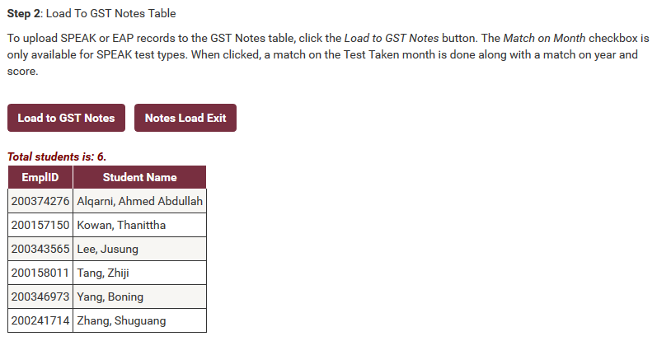

Click the Notes Load Exit button to reset back to the Load SPEAK or EAP to Notes section. Click the Load to GST Notes button to load the displayed test score data to the Notes table. The list will redisplay with a new Load Result column that displays the results of the load (see below).

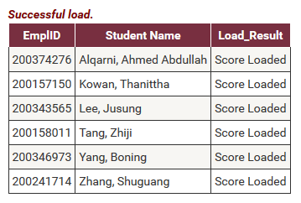

Menu to Clean Up Notes Table

The menu to Clean Up Notes Table page is show below. The Select Clean Up Action options are:
- Remove SPEAK or EAP Scores for Date
- Remove SPEAK Duplicates (Same SPEAK Date and Score)
- Report SPEAK Dates with Multiple Scores
- Sort SPEAK Scores By Date
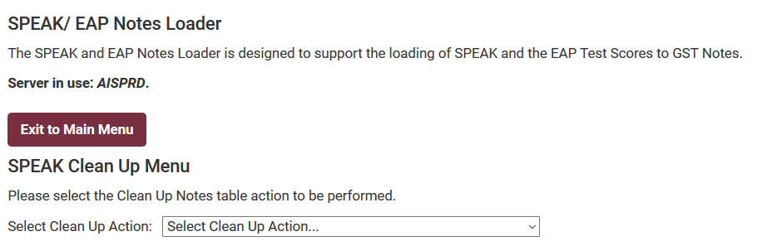

Remove SPEAK or EAP Scores for Date

The Remove SPEAK or EAP Scores for Date option allows the user to remove test scores from the GST Notes table. When this option is selected, new menu items are displayed to define the test score type, either SPEAK or EAP, and the Test Date (see below).

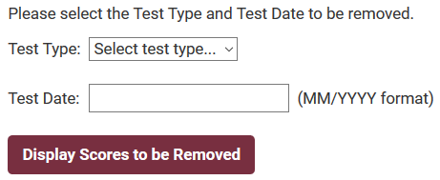

When the Display Scores to be Removed button is clicked, a list of the identified test scores from the GST Notes table is displayed (see below). The Remove Scores button and the Download to Spreadsheet button are also displayed. Click the Download to Spreadsheet button to create a Excel spreadsheet of the test score list. When the Remove Scores button is clicked, a pop-up warning is displayed (see below) to allow the user to continue to delete the test scores from the GST Notes table or cancel the delete.

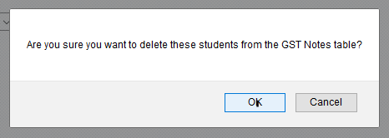

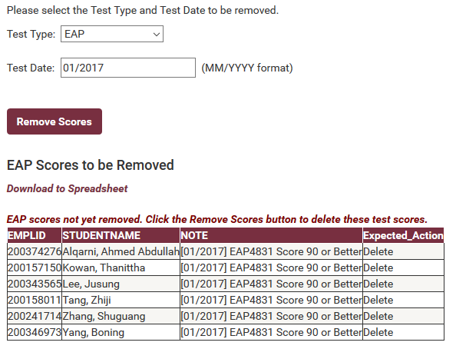

Remove SPEAK Duplicates (Same SPEAK Date and Score)

When the Remove SPEAK Duplicates option is selected, the application immediately executes a routine to remove all SPEAK duplicates from the GST Notes table. Upon completion, the routine displays the status of the run as shown below.

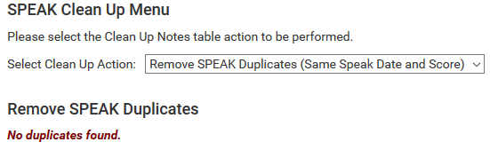

Report SPEAK Dates with Multiple Scores

When the Report SPEAK Dates Multiple Scores option is selected, the application immediately executes a routine to report all SPEAK dates with test date repeats from the GST Notes table. Upon completion, a list of reported duplicate SPEAK dates is displayed, as shown. This report is used to cleaned up the Notes table manually, if necessary.

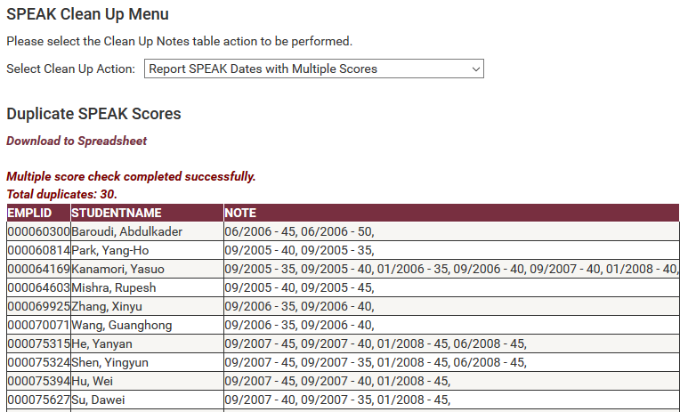

Sort SPEAK Scores By Date

When the Sort SPEAK Scores by Date option is selected, the application immediately executes a routine to sort SPEAK test score data by date on the GST Notes table. If there are duplicate SPEAK dates, a report is created, as shown.

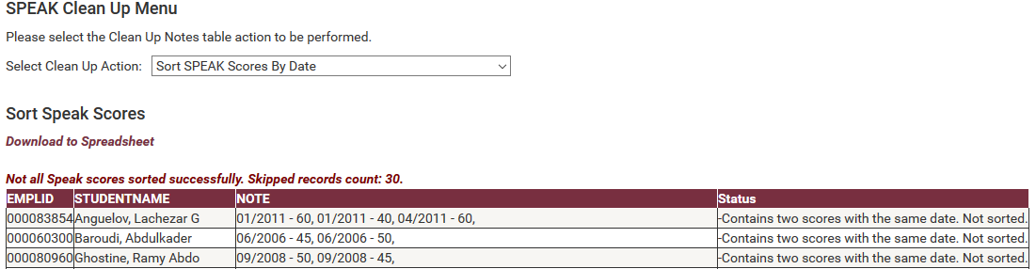

Upload SPEAK or EAP Data to Archive Table

The Upload SPEAK or EAP to Archive Table option loads SPEAK and EAP test score data to the GST Archive table. This application functions the same way the Center for Intensive English Studies upload works. Please refer to the Center for Intensive English Studies User’s Quick Guide at the top of this document.

Review/ Delete Archive Data

The Review/ Delete Archive Data option allows the user to review or delete data from the GST Archive table. This application functions the same way the Center for Intensive English Studies upload works. Please refer to the Center for Intensive English Studies User’s Quick Guide at the top of this document.

